**MICROSCOPY**

Microscopy is a way to uses of Microscope is called Microscopy.

**MICROSCOPE**

the technical field of using microscopes to view objects and areas of objects that cannot be seen with the naked eye.

**RESOLUTION**

Resolution is the ability basically resolve two objects and separate them from each other.

It is the limit up to which two small objects are seen as Separate.

**BRANCHES OF MICROSCOPY**

There are three well-known branches of microscopy: optical, electron, and scanning probe microscopy, along with the emerging field of X-ray microscopy.

1. **OPTICAL MICROSCOPY**
2. **ELECTRON MICROSCOPY**
3. **SCANNING PROBE MICROSCOPY**

**SUPER-RESOLUTION MICROSCOPY**

**It** is a series of techniques in optical microscopy that allow such images to have resolutions higher than those imposed by the diffraction limit, which is due to the diffraction of light.

Super-Resolution Microscopy Abbreviated SIM

[3] Super-resolution imaging techniques rely on the near-field (photon-tunneling microscopy[4] as well as those that use the Pendry Superlens and near field scanning optical microscopy) or on the far-field. Among techniques that rely on the latter are those that improve the resolution only modestly (up to about a factor of two) beyond the diffraction-limit, such as confocal microscopy with closed pinhole or aided by computational methods such as deconvolution[5] or detector-based pixel reassignment (e.g. re-scan microscopy,[6] pixel reassignment[7]), the 4Pi microscope, and structured-illumination microscopy technologies such as SIM[8][9] and SMI.

**OPTICAL IMAGING**

Optical imaging uses light and special properties of photons to obtain detailed images of organs, tissues, cells and even molecules. The techniques offer minimally or non-invasive methods for looking inside the body.

OR

Medical optical imaging is the use of light as an investigational imaging technique for medical applications, pioneered by American Physical Chemist Britton Chance. Examples include optical microscopy, spectroscopy, endoscopy, scanning laser ophthalmoscopy, laser Doppler imaging, and optical coherence tomography. Because light is an electromagnetic wave, similar phenomena occur in X-rays, microwaves, and radio waves.

**FLUORESCENCE**

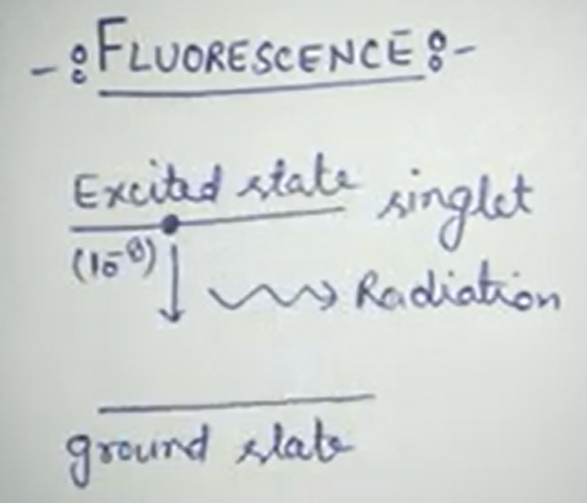

**FLOURSENCE MICROSCOPY**

**WIDEFIELD-BASED APPROACHES**

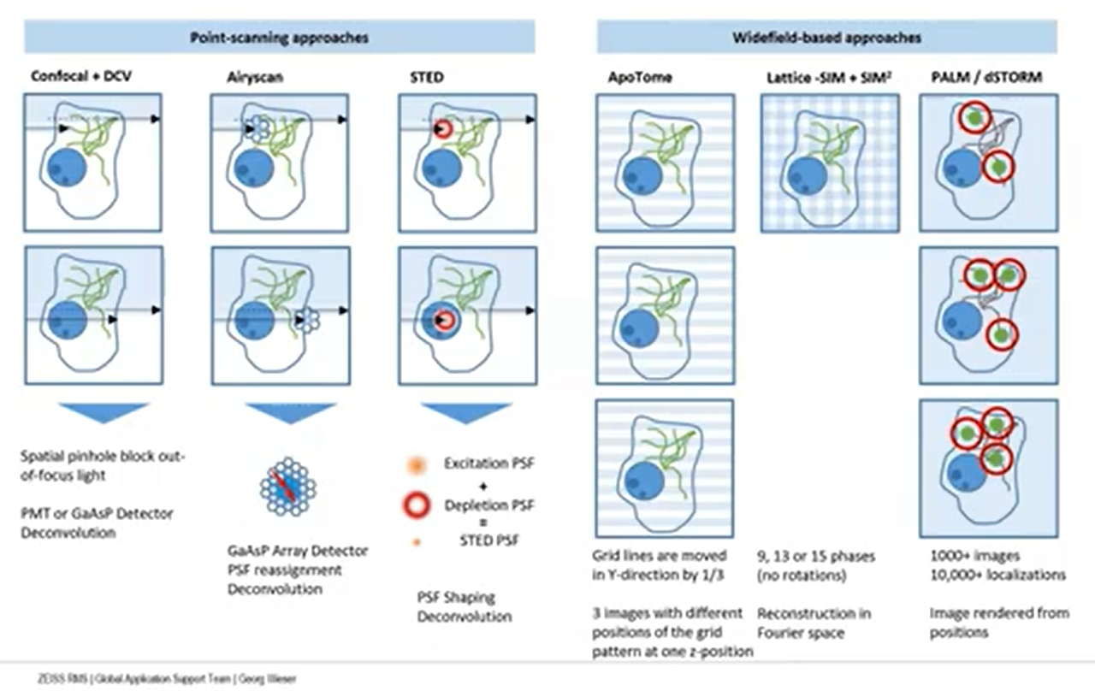

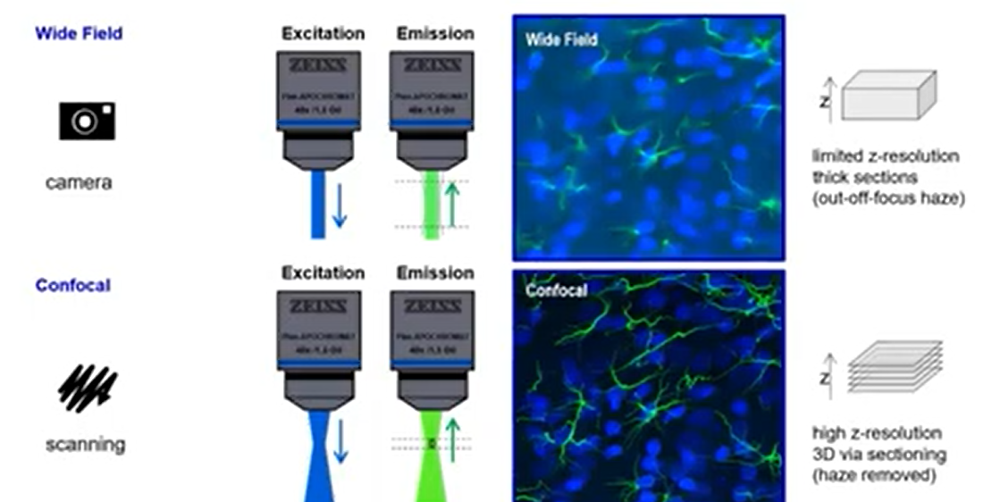

**CONFOCAL**





**POINT-SCANNING APPROACHES**

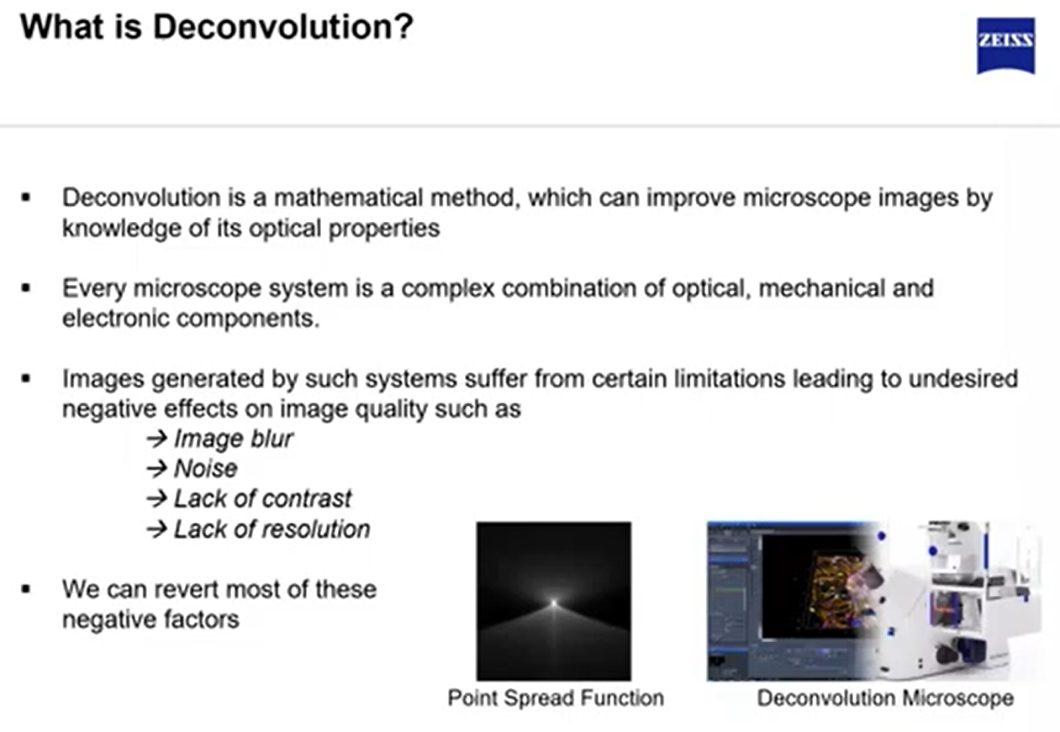

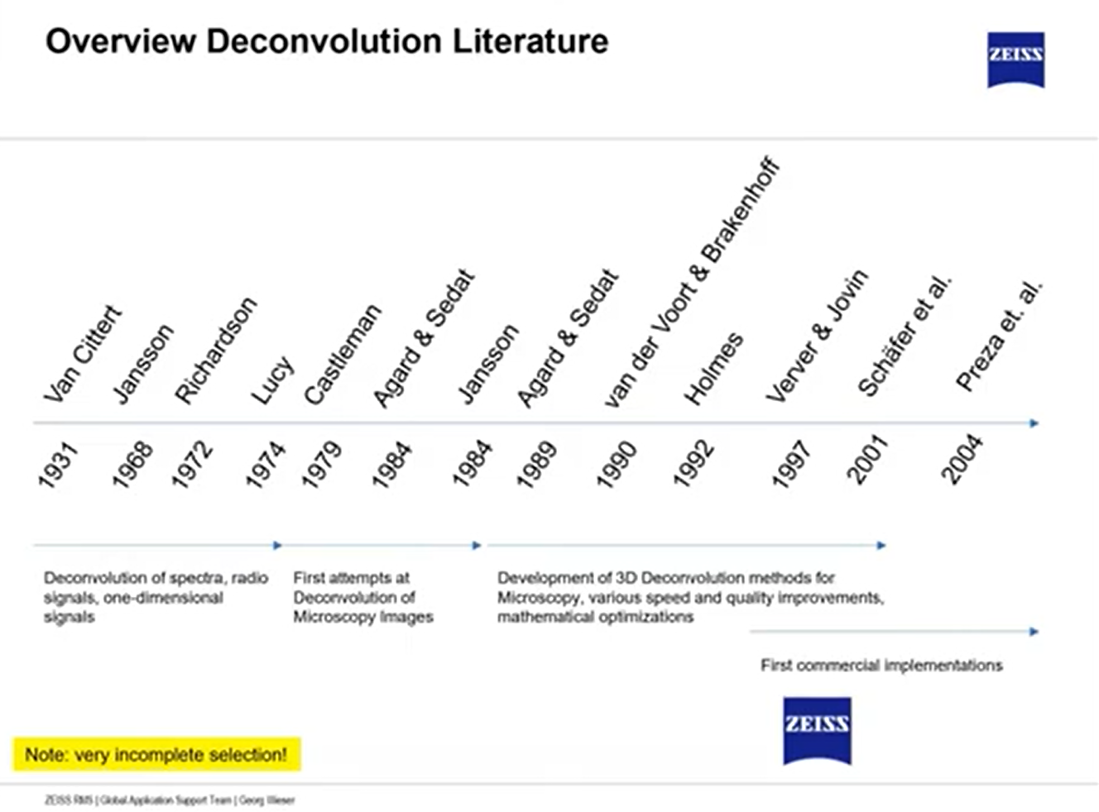

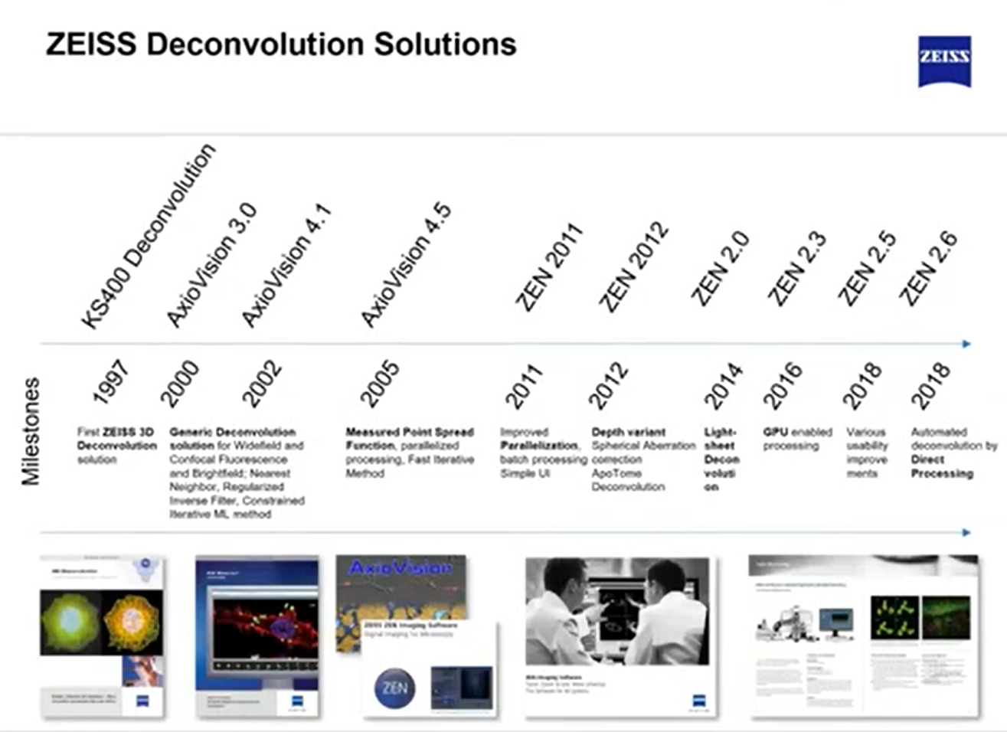

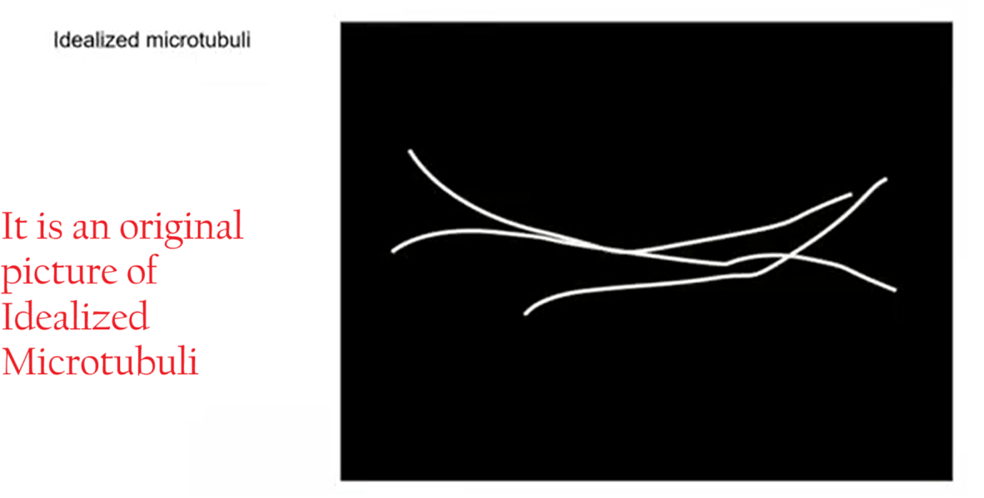

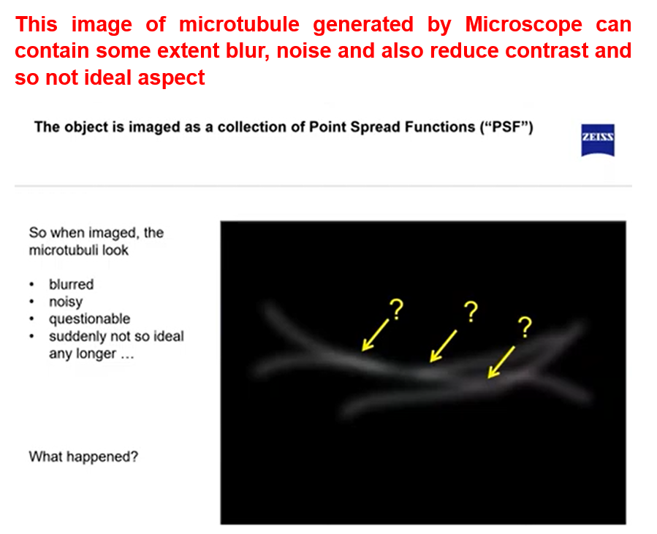

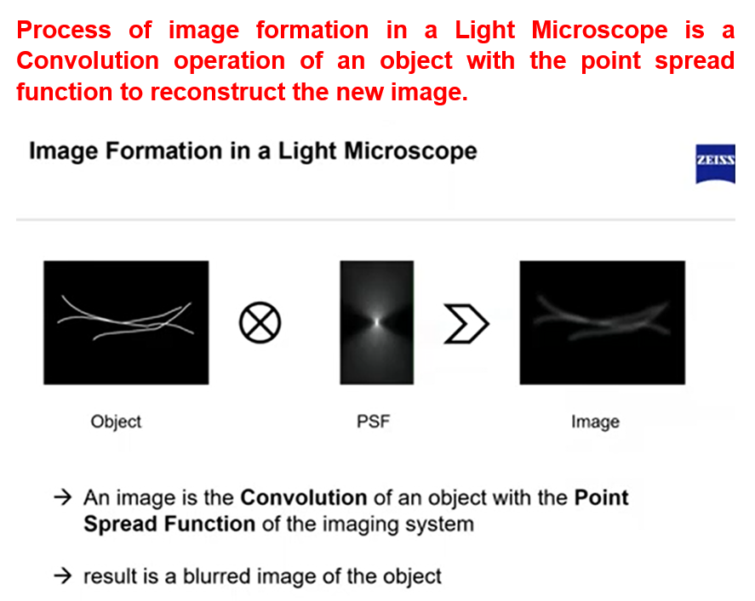

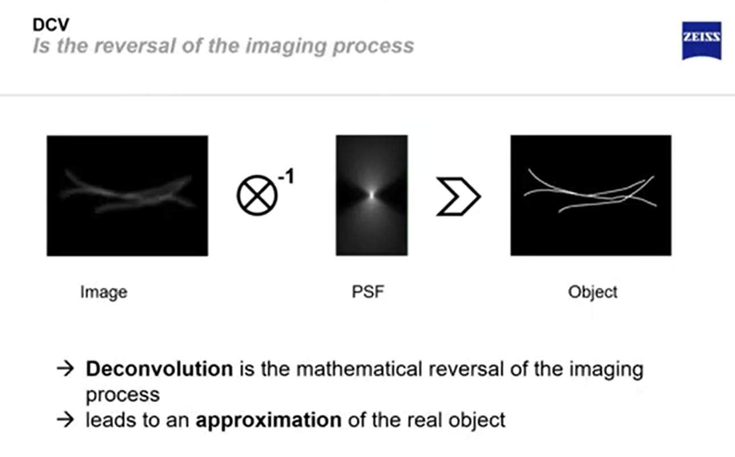

There are a lot of Deconvolution Methods available in the Market

